**NAMA : AMALIA FANDANING TYAS**

**NIM : 19051397012**

**PRODI : D4 MANAJEMEN INFORMATIKA**

**JAWABAN**

1. **DIAGRAM VENN**

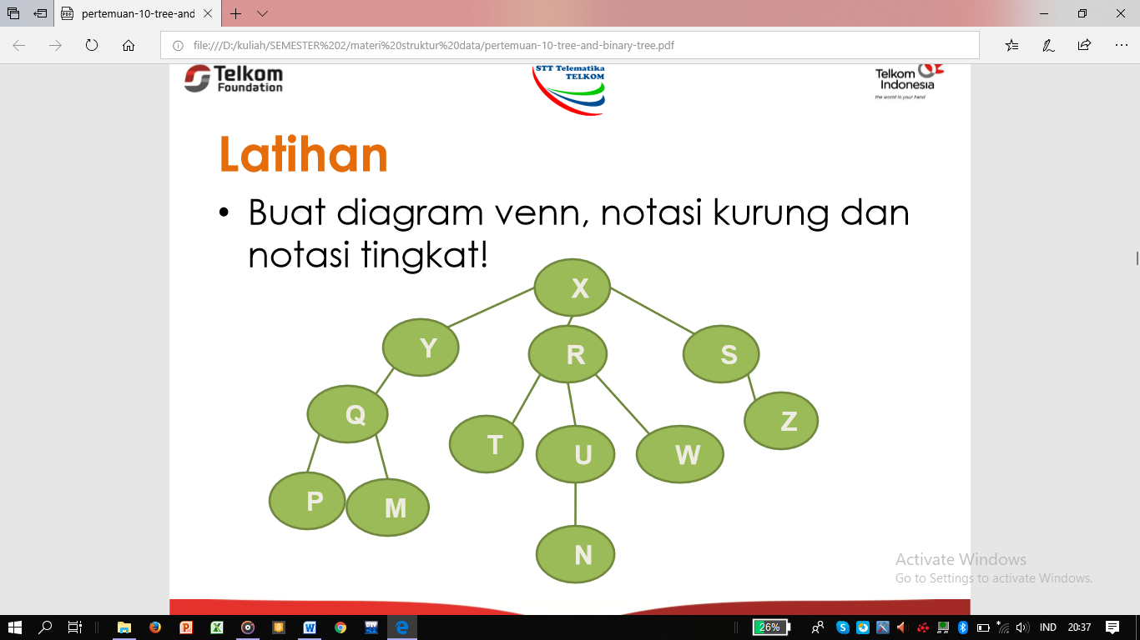

**TINGKAT 3**

**TINGKAT 2**

**TINGKAT 1**

**TINGKAT 0**

1. **NOTASI TINGKAT**

|  |  |  |  |
| --- | --- | --- | --- |
| **X** |  |  |  |
|  | **Y** |  |  |
|  |  | **Q** |  |
|  |  |  | **P** |
|  |  |  | **M** |
|  | **R** |  |  |
|  |  | **T** |  |
|  |  | **U** |  |
|  |  |  | **N** |
|  |  | **W** |  |
|  | **S** |  |  |
|  |  | **Z** |  |

1. **NOTASI KURUNG**

(X ( Y (Q ( P, M ), R (T, U (N), W), S (Z)))

1. **IDENTIFIKASIKAN**
2. Ancestor (N) = U, R, X
3. Descendant (Y) = Q
4. Parent (Z) = S
5. Child (Q) = Y, M
6. Sibling (U) = T, W
7. Size = 12
8. Height = 4
9. Root = X
10. Leaf = P, M, T, N, W, Z
11. Degree (R) = 3

**BINNARY TREE**

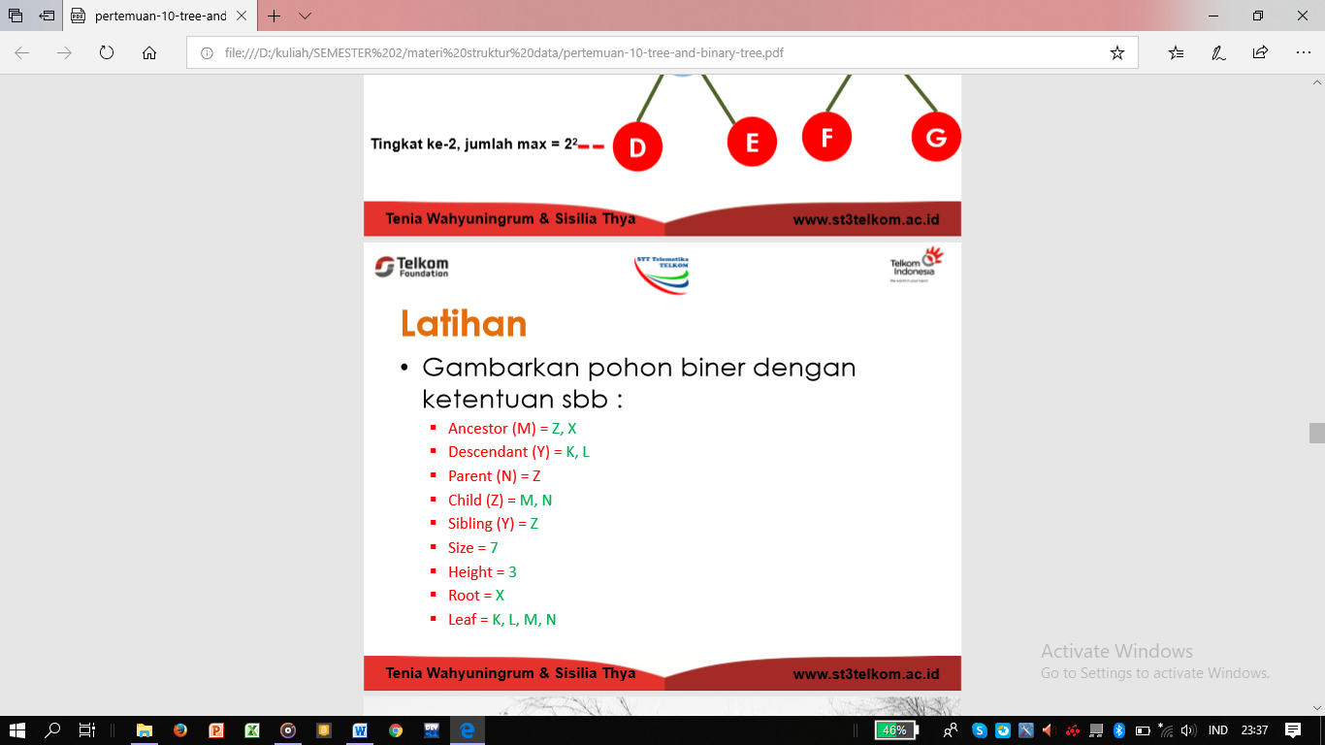

**PENELUSURAN POHON BINER**

**LATIHAN 1**

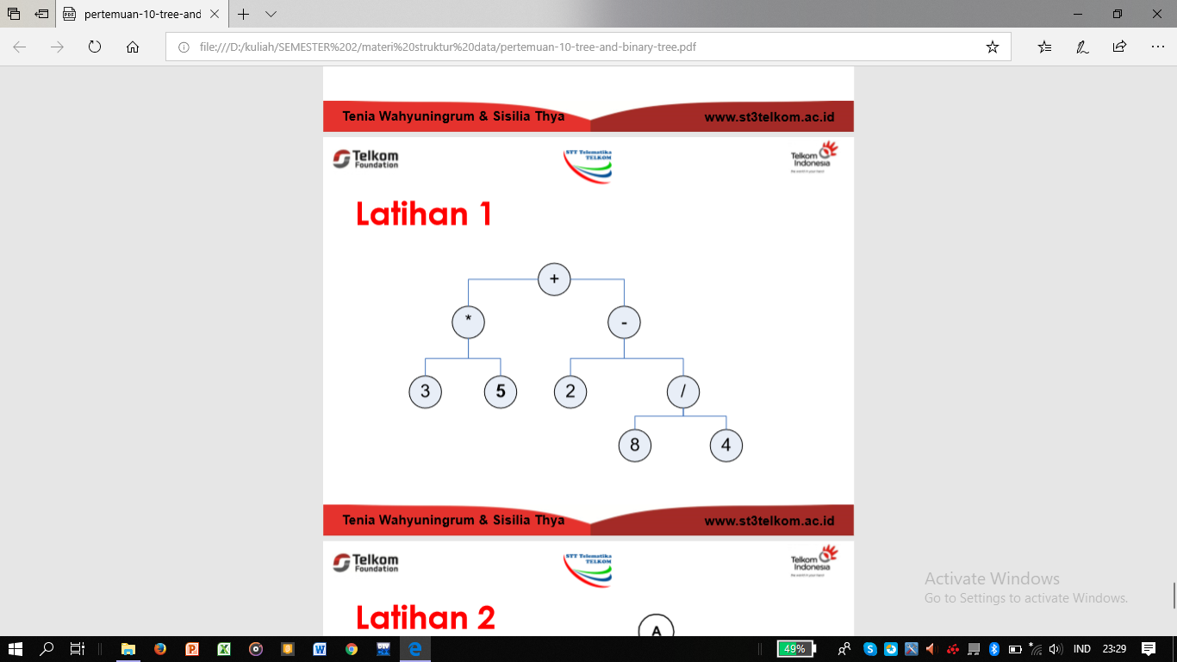

1. PreOrder : + * 3 5 – 2 / 8 4
2. InOrder : 3 * 5 + 2 – 8 / 4
3. PostOrder : 3 5 * 2 8 4 / - +

**LATIHAN 2**

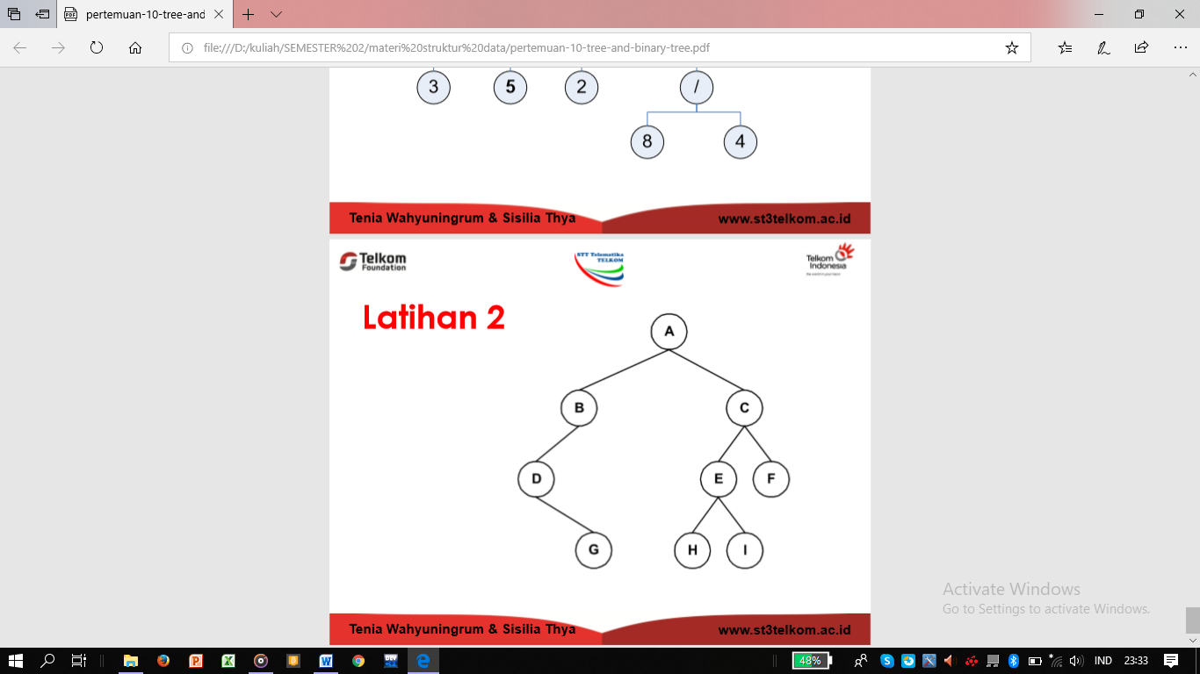

1. PreOrder : A B D G C E H I F
2. InOrder : D B G A H E I C F
3. PostOrder : G D B H I E F C A